京都産業大学
Mauro Morandi has lived alone on Italy's Budelli Island for 31 years.
In 1989, the engine in his boat died, and he washed up on the coast of Budelli Island,
located between Sardinia and Corsica. By chance, Morandi learned that the island's caretaker
was retiring, so he sold his boat and took over the job. Thirty-one years later, Morandi remains
the sole resident and keeper of the island.
In the early 1990s, Budelli Island's Pink Beach was named a natural treasure
by the Italian government. The beach was closed off to protect its delicate ecosystem,
and only some areas were left accessible to visitors. The island rapidly went
from hosting thousands of people a day to usually hosting just one.
"I will never leave. I hope to die here and have my ashes scattered in the wind," says Morandi,
who is now 81. He believes all life eventually returns to the Earth —
that we are all part of the same energy.
This belief is why he stays on the island even without any pay.
Despite his dislike of people, Morandi guards Budelli's environment with passion and educates
summertime visitors about the ecosystem and how to protect it. "I'm not a scientist," Morandi says.
"Yes, I know the names of plants and animals, but my work is very different from this.
To be able to care for a plant is a technical task —
I try to make people understand why the plant needs to live."
Morandi said that teaching people how to see beauty will save the world from being wrongly used.
"I would like people to understand that we must try not to look at beauty,
but feel beauty with our eyes closed," he says. Winters on Budelli are both beautiful and lonely.
Morandi endures long stretches of time—more than 20 days—without any human contact.
He finds comfort in spending this time thinking, and often sits on the beach with nothing
but the sounds of the wind and waves to break the silence. "I'm sort of in prison here," he says.
"But it's a prison that I chose for myself." Morandi passes the time with creative activities.
He makes pieces of wood into sculptures, finding faces hidden in their unusual shapes.
He reads eagerly and studies the wisdom of Greek philosophers and literary talents.
He takes pictures of the island, marveling at how it changes from hour to hour, season to season.
When Wi-Fi inevitably found its way to this nearly empty island,
Morandi adopted it and began sharing his island paradise with the world through social media.
Embracing this new form of communication is his compromise for a larger purpose-to create
a bond between people and nature by exposing them to its beauty.
Morandi hopes this bond will motivate people to care for the planet wherever they are.
"Love is an absolute consequence of beauty, and the opposite is also true,"
Morandi says. "When you love a person deeply you see him or her as beautiful,
but not because you see them as physically beautiful-you identify with them,
you become a part of them and they become a part of you. It's the same thing with nature."

本文の内容と最もよく合うものを選んでください。
7 According to the passage, Mauro Morandi originally came to Budelli when he ( ) .
1. was required to travel there for his job
2. saw beautiful pictures of the scenery on social media
3. landed by accident after experiencing a boating problem
4. became tired of people and searched for a place to escape society

8 In the past, thousands of people visited Budelli daily, but now ( ) .
1. Morandi is often the only person on the island
2. only Morandi and the retired caretaker live there
3. the Italian government pays Morandi to keep people away
4. the island is completely closed to humans to protect its beach

9 When people visit Budelli in the summer, Morandi ( ) .
1. explains to them why they must let him die on the island
2. shares his scientific knowledge about plant and animal names
3. asks them to help with the technical tasks of caring for plants
4. teaches them about the island's environment and how to preserve it

10 Morandi spends his time on Budelli ( ) .
1. searching for hidden visitors to the island
2. enjoying artistic hobbies and reading books
3. trying to find ways to escape his island prison
4. planning for his next 20 days of human contact

11 How does Morandi use social media now that Budelli has Wi-Fi ?
1. He tries to motivate people to live alone on other islands.
2. He encourages people to look for new forms of communication.
3. He shares the beauty of the island to connect people with nature.
4. He communicates with other people who have been exposed to loneliness.

12 This passage shows us that Morandi ( ) .
1. regrets his decision to stay on Budelli now that he is old
2. wishes there were more visitors to the island in the winter
3. wants to create a stronger bond between himself and other people
4. uses his unique situation to encourage others to care for the planet

13 What would be the best title for this passage?
1. The Beach Resort of Budelli
2. Budelli: A Man and The Island
3. Mauro Morandi: A People Person
4. Protecting the Italian Environment

Mauro Morandi has lived [alone] [on Italy's Budelli Island] [for 31 years] .
S V
[In 1989], the engine [in his boat] died , and he washed up[ on the coast of Budelli Island] ,
S V S V
located [between Sardinia and Corsica] .

being located [between Sardinia and Corsica] . ・・・分子構文
and Budelli Island was located [between Sardinia and Corsica] .
接 S V 接続詞 as though and

マウロ・モランディーさんは、３１年間イタリアのブデリ島に一人で暮らしています。
１９８９年にボートのエンジンが壊れブデリ島の海岸に流れ着きました。

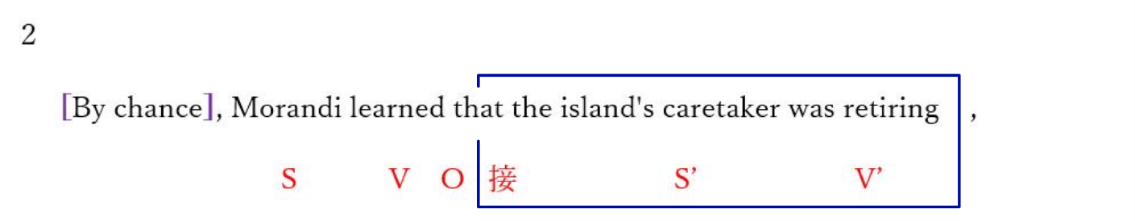
so he sold his boat and took over the job.
S V O V O
[Thirty-one years later] , Morandi remains the sole resident and keeper( of the island).
S V O
偶然、その島の世話役は引退していることをモランディーさんは知った。
それで彼はボートを売り、その仕事を引き継いだ。
その後３１年間、一人の住人であり、島の世話役である。

3
[ In the early 1990s], Budelli Island's Pink Beach was named a natural treasure
S V C
[by the Italian government] . The beach was closed off [to protect its delicate ecosystem] ,
S V
and only some areas were left accessible [to visitors] .
S V C
１９９０年代初頭にイタリア政府によってブデリ島のピンクビーチは、自然遺産に指定された。
繊細な生態系を守るために、そのビーチは閉鎖されました。
そしていくつかの地域だけが訪問者にアクセス可能とされた。

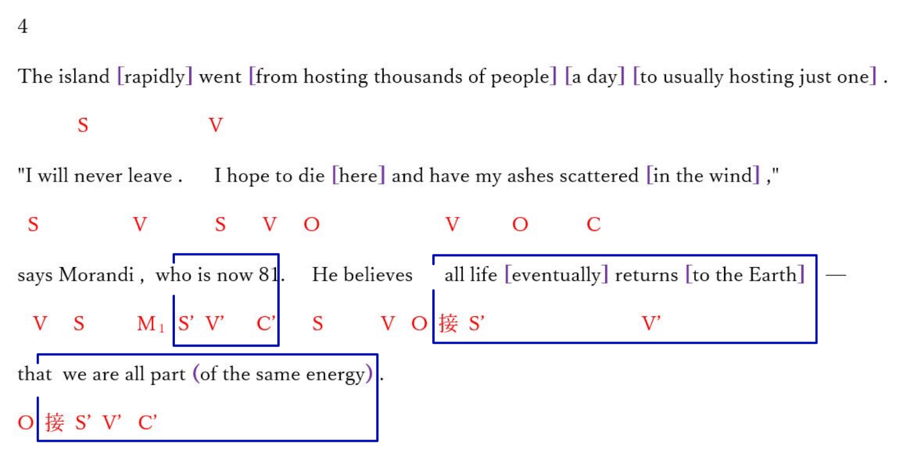

島にとって日に数千人の訪問者から普通一人だけの滞在者に急速になった。
（島にとって日に数千人の訪問者をもてなすことから普通一人だけのもてなしに急速になった）
「私は決してここを去らない。私はここで死に私の灰は風に吹かれてもらいたい。」
と８１歳のマラディーさんは言います。すべての命は最後には地球に戻るつまり
我々はみんな同じエネルギーの一部であると彼は信じる。
5
This belief is [why] he stays [on the island even without any pay] .
S V C S’ V’
この信念が、彼がこの島に無給でさえ残る理由である。

[Despite his dislike of people] , Morandi guards Budelli's environment [with passion]
S V O
and educates summertime visitors [about the ecosystem] and how to protect it.
V O O O’
マラディーさんは人を嫌っているにも関わらずブデリ島の環境を熱い思いで守り
島の生態系とその保護の仕方について夏の訪問者に教える。

"I'm not a scientist," Morandi says.
S V C S V
"Yes, I know the names (of plants and animals) , but my work is very different [from this] .
S V O S V C
マラディーさんは言います。「私は、科学者ではない。私は動植物の名前を知っています。
しかし私の仕事はそういうことではない。

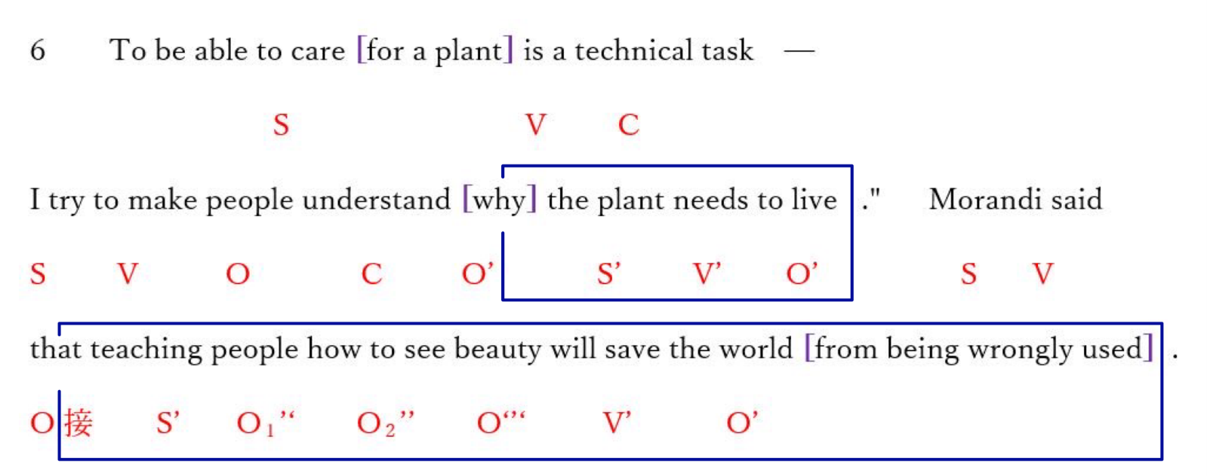

植物を世話できることは技術的な仕事です。
なぜ植物が生きるために必要かを人々に理解させようとします。
人々に（地球の）美しさの見方を教えることは世界を間違った扱われ方から救うと
モラディーさんは言います。

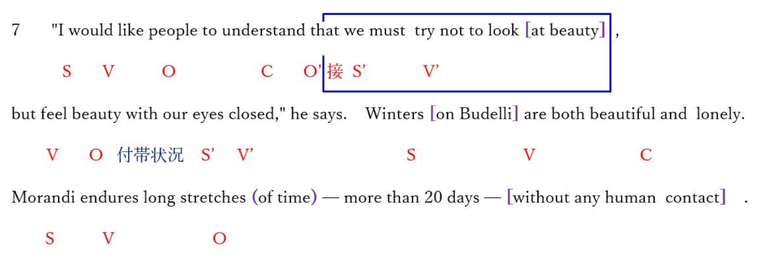
「美というものを見るのではなく目を閉じて感じることを私は理解してもらいたい。」
と彼は言う。ブデリ島の冬は美しく寂しい。他の人間と接触しない２０日以上の長い時間を
モラディーさんは耐える。

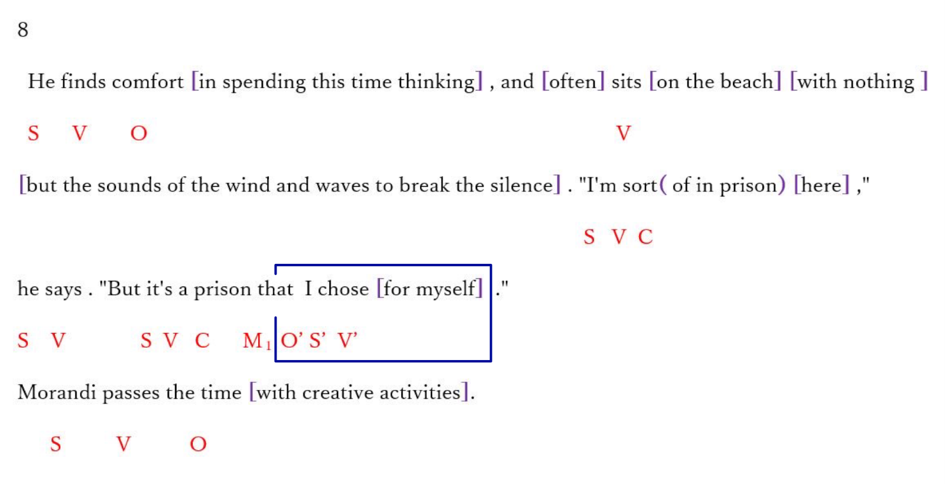
思考しながらこの時間を過ごすことに彼は快適さを見つける。そして静けさを引き裂く風と波の
音以外何もないビーチで彼は座る。「ここで私は一種の囚人である。
しかし、自ら選んだ囚人である。」と彼は言う。マラディーさんは、創造活動で時間を過ごす。

9 He makes pieces of wood [into sculptures] , finding faces (hidden [in their unusual shapes]).
S V O and he finds
He reads [eagerly] and studies the wisdom (of Greek philosophers and literary talents) .
S V O
彼は木片で彫刻を作り、普通ではない形の中に隠された顔を見つける。
ギリシャ哲学や文学的才能の知恵を熱心に読み研究する。

He takes pictures (of the island),
S V O
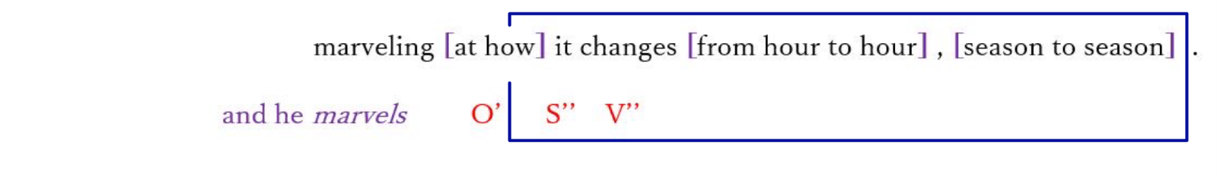
彼は島の写真を撮り、島が時から時に 季節から季節へどのように変わるかに驚く。

10 When Wi-Fi [inevitably] found its way [to this nearly empty island] ,
S’ V’ O’
Morandi adopted it and began sharing his island paradise [with the world] [through social media] .
S V O V O O’
Embracing this new form of communication is his compromise [for a larger purpose]
S O’ V O
---- to create a bond(between people and nature) [by exposing them to its beauty] .

この空っぽに近い島にも必然的にWi-Fiがつながった時、マラディーさんはそれを採用し
ソーシアルメディアを通じて世界にこの楽園の島を分かち合い始めた。彼にとって
コミュニケーションのこの新しい形態を受け入れることは、より大きな目的のための妥協で
ある。すなわち、人々に自然をさらすことによって人と自然の間のきずなを創り出すために。
１１
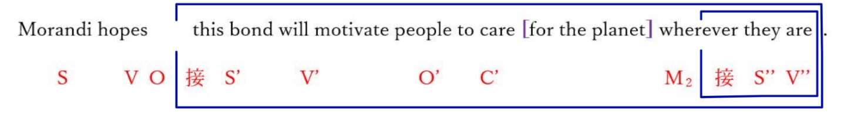

人々がどこにいようと、この絆がこの地球を大事にする動機になることを
マラディーさんは望む。

関係代名詞 S that S’ V’ V 名詞 S V
接続詞 S V that S’ V’

１２
"Love is an absolute consequence of beauty, and the opposite is [also] true,"
S V C S V C
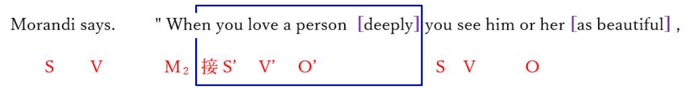
but not because you see them [as physically beautiful] ---- you identify [with them] ,
S’ V’ O’ S V
you become a part (of them) and they become a part (of you) . It's the same thing [with nature]."
S V C S V C S V C

「愛は美しさの絶対的な結果であり、その逆もまた真実です。」とマラディーさんは言います。
「人を深く愛するとき、美しいものとして人を見る。しかし（それは）物理的に美しいもの
として相手を見るのではなく自分を相手と同一視しているからである。
あなたは全体の中の一部であり、全体はあなたの一部になる。自然に対しても同じことである。
設問

Mauro Morandi has lived alone on Italy's Budelli Island for 31 years.
In 1989, the engine in his boat died,
and he washed up on the coast of Budelli Island, located between Sardinia and Corsica.

問７ According to the passage, Mauro Morandi originally came to Budelli when he ( ) .
1. was required to travel there for his job
2. saw beautiful pictures of the scenery on social media
3. landed by accident after experiencing a boating problem
4. became tired of people and searched for a place to escape society

By chance, Morandi learned that the island's caretaker was retiring ,
so he sold his boat and took over the job. Thirty-one years later,
Morandi remains the sole resident and keeper of the island.

問８ In the past, thousands of people visited Budelli daily, but now ( ) .
1. Morandi is often the only person on the island
2. only Morandi and the retired caretaker live there
3. the Italian government pays Morandi to keep people away
4. the island is completely closed to humans to protect its beach

Despite his dislike of people, Morandi guards Budelli's environment with passion and educates
summertime visitors about the ecosystem and how to protect it. "I'm not a scientist," Morandi says.
"Yes, I know the names of plants and animals, but my work is very different from this.

問９ When people visit Budelli in the summer, Morandi ( ) .
1. explains to them why they must let him die on the island
2. shares his scientific knowledge about plant and animal names
3. asks them to help with the technical tasks of caring for plants
4. teaches them about the island's environment and how to preserve it

Morandi passes the time with creative activities.
He makes pieces of wood into sculptures, finding faces hidden in their unusual shapes.
He reads eagerly and studies the wisdom of Greek philosophers and literary talents.
He takes pictures of the island, marveling at how it changes from hour to hour, season to season.

問１０ Morandi spends his time on Budelli ( ) .
1. searching for hidden visitors to the island
2. enjoying artistic hobbies and reading books
3. trying to find ways to escape his island prison
4. planning for his next 20 days of human contact

When Wi-Fi inevitably found its way to this nearly empty island,
Morandi adopted it and began sharing his island paradise with the world through social media.
Embracing this new form of communication is his compromise for a larger purpose
----- to create a bond between people and nature by exposing them to its beauty.
Morandi hopes this bond will motivate people to care for the planet wherever they are.

問１１ How does Morandi use social media now that Budelli has Wi-Fi ?
1. He tries to motivate people to live alone on other islands.
2. He encourages people to look for new forms of communication.
3. He shares the beauty of the island to connect people with nature.
4. He communicates with other people who have been exposed to loneliness.

"Love is an absolute consequence of beauty, and the opposite is also true,"
Morandi says. "When you love a person deeply you see him or her as beautiful,
but not because you see them as physically beautiful ----- you identify with them,
you become a part of them and they become a part of you. It's the same thing with nature."

問１２ This passage shows us that Morandi ( ) .
1. regrets his decision to stay on Budelli now that he is old
2. wishes there were more visitors to the island in the winter
3. wants to create a stronger bond between himself and other people
4. uses his unique situation to encourage others to care for the planet

問１３ What would be the best title for this passage?
1. The Beach Resort of Budelli 2. Budelli : A Man and The Island
3. Mauro Morandi: A People Person 4. Protecting the Italian Environment

